Connecting B228 to Bosch 4000

When connecting the B228 expander to a Bosch 4000, there are module addresses to consider. If using addresses 2 and 3 for zones 17 – 24 and zones 25 – 32 the zones are automatically assigned to the B228 expanders.
If B228 expander is adressed 1 for zones 9 – 16 you must reassign the zones form the panel to use the expander zones. This can only be done withy A-Link Plus software v 1.21.
Control panel configuration - Zone Config – Zone Source

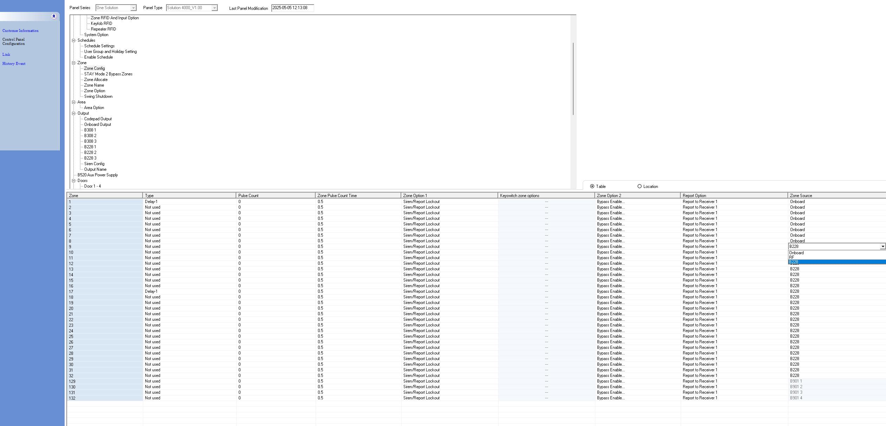
By default, zones 9 – 16 are assigned to the panel in zone doubling configuration. If using the B228 expanders zone doubling is no longer available.

