**Access door setup for Bosch 4000**

**To enable Door via Codepad:**

Go to location**13098** and choose how many doors are required.

Default is 0 – All doors disabled

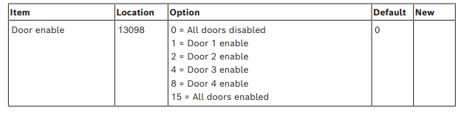

**Codepad assigned door:**

This option is assigning door or doors to codepads for adding access cards

and cycling door operations. Each codepad and be assigned door/s.

By default this is set to **[15]** – No door is assigned

If this is left as **[15]** – you will ***not*** be able to:

* Cycle the door operation
* Add access card users via the codepad

**Assign Door 1 to Codepad 1**

Location **552 –** Enter **1 -** to assign Door 1 to Codepad 1

Enter **1234 # 552 # 1 \***

**Assigning Access Card/Tag to User:**

* Using the Master Code, you can add/ delete access cards/tags just like user codes and remotes.
* Access card credentials are between **[601 – 664]** which like the remotes are assigned to users **1 - 64** respectively.
* To add an access card credential:

Enter **Master code + 1 # + 601 + #** Present card at reader (2 beeps are heard when successful).

Enter **25801# 601#**  Present Card/tag at reader

* To delete access card/tag

Enter **Master code + 1 # + 601 + # then \*** (2 beeps are heard if successful).

Enter **25801# 601#** **\*** to delete

As mentioned, there are **32** zones on the 4000, there are an additional **4** zones for the access door control. One for each door module **[ B901]**

These are programmed to same way a normal panel zone and uses the same structure as the 32 zones on the 4000.

* These zones will show up as zones **129 – 132** on the alarm system
* Program door zone 129 for entry delay 1 on the Door module 1

**1234# 13252# 2 \***

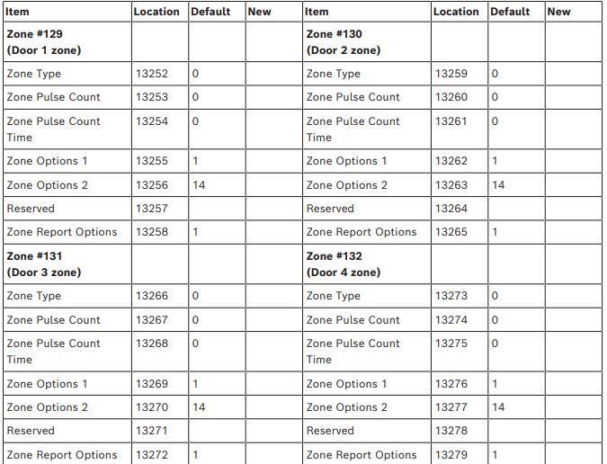

**Access Door Programming Via Alink Software**

**Common Door Options**

**Door Name** - *Name of Door*

**Door Enable** - *Yes or No*

**Exit request** - *RTE device*

**Auto door** - *Unlock during disarm*

**Fire unlock** - *Unlocks during FIRE event. Zone to be programmed as a fire zone-type 13*

**Strike Time -** *Unlock time of door*

*Default is 10 seconds*

**Failure Mode:**

***Fail Secure -*** *Door remains locked when B901 module is offline*

***Fail Safe –*** *Access module releases door when B901 module loses communications with 4000 panel*

**Global Access Settings:**

* This is for selecting which weigand format to use. Currently only 3 options.
* 26 bit, 37 bit No site code and 37 bit with site code

**Keypad Assigned Door:**

* Assign a codepad to an access door.

**Assigning user cards/tags:**

Enter ***User Name***, ***Area User Authority***, ***Site Cod****e* and ***Card Number***details if required

**Zone Programming**

* Here you can program the zone for each Door module.
* Each Door module has one zone available for Door input monitoring

**Schedule Settings**

* This is where you create schedules/timezones for ***Doors*** and ***User Groups.*** *2 x schedules will need to be programmed per event eg: Door unlocked during business hours – 1 for* ***unlock*** *time and 1 for* ***lock*** *time*
* **Function: No Schedule** -*Disabled*

**Lock Door** *– Locked during valid Schedule*

**Unlock Door** – *Unlocked during valid Schedule*

**Secure Door** – *Locks during valid Schedule*

**Activate User** – *User allowed access during valid Schedule*

**Deactivate User** – *User denied access during valid Schedule*

**Sunday through Saturday** *Yes/No – enable or disable for each day.*

* **On Date** Yes/No – *enable/disable user to edit schedule via codepad.*
* **Time** *Time of day that the schedule starts or is valid*
* **Date** *Start date for the event schedule to start – day and month only*

**Schedule holiday option**

3 x options: **Ignore Holiday setting**: *Schedule still valid during holidays programmed*

**Holiday will do schedule:** *Will operate schedule if no days set in schedule*

**Holidays are exception day:** *Schedule does not operate on holiday programme*

**User Group And Holiday Settings**

* Up to 8 User Groups
* 1 Holiday schedule

Users that are assigned User Groups can be assigned to a schedule to restrict access to the door.

* Select **[View in Setting]** section of the **User Group**
* Select the users you want have in that **User Group** and click **OK**

**User Group And Holiday Settings**

* Up to 8 User Groups
* 1 Holiday schedule

The Holiday schedule is also setup in this area.

* Select **[View in Setting]** section of the **Holidays** section
* Select the dates on the monthly calender and select **OK** when done

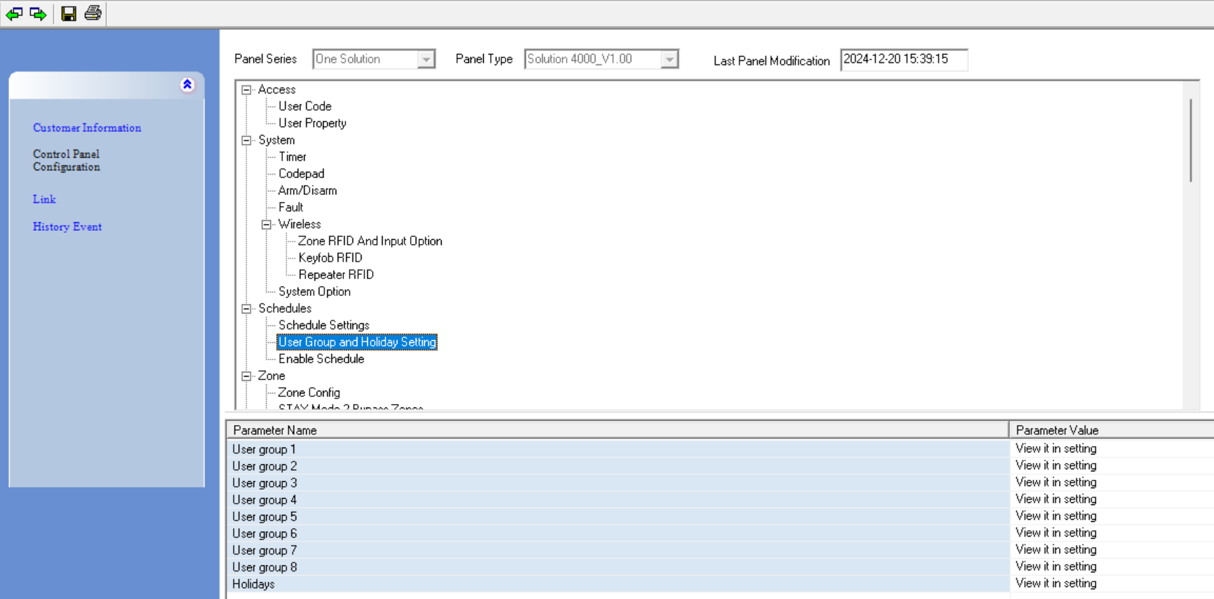

**Enable Schedule**

In the Option section, just enable the schedule number to activate that schedule

