How to program IP camera on Poe switch and connect to NVR

- Using SADP tool find the camers on the network, Make sure the PC and NVR is connected to the same network

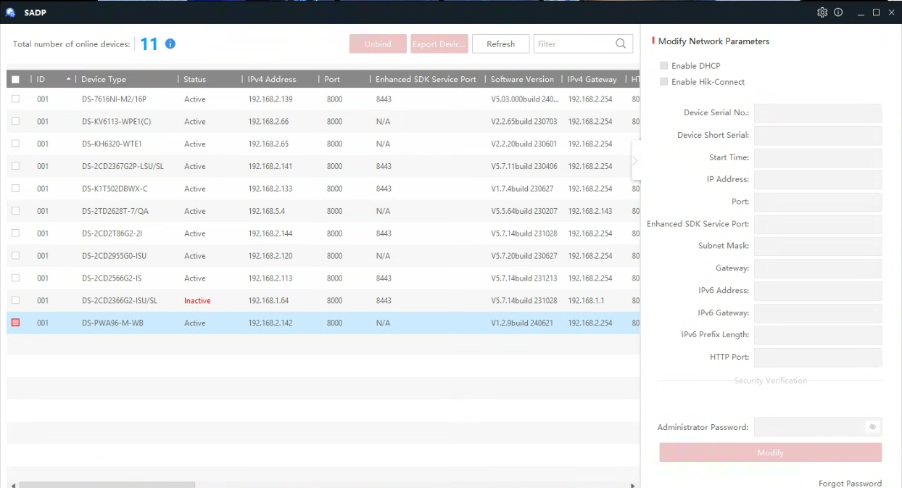

- New camera/s will show up as inactive with a default IP address 192.168.1.64. Click on the square box on the left of the camera model to select the camera.

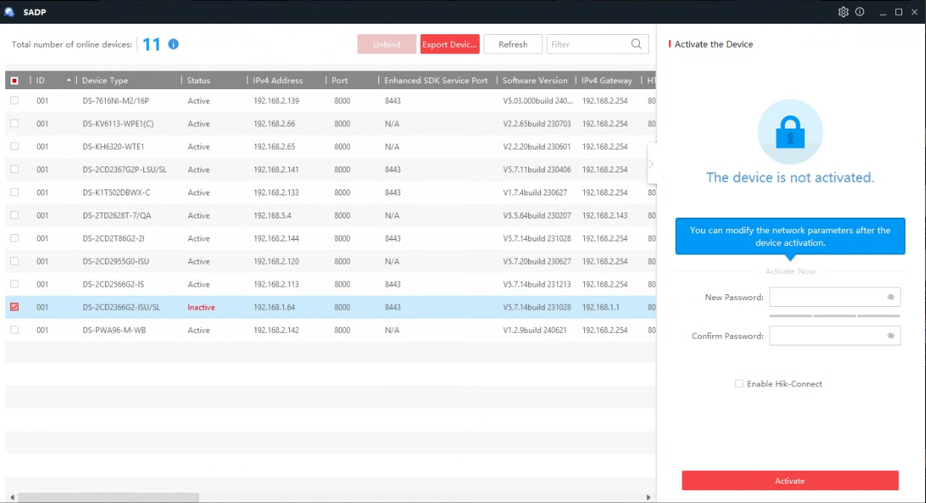
- Create the password for the camera and then Activate
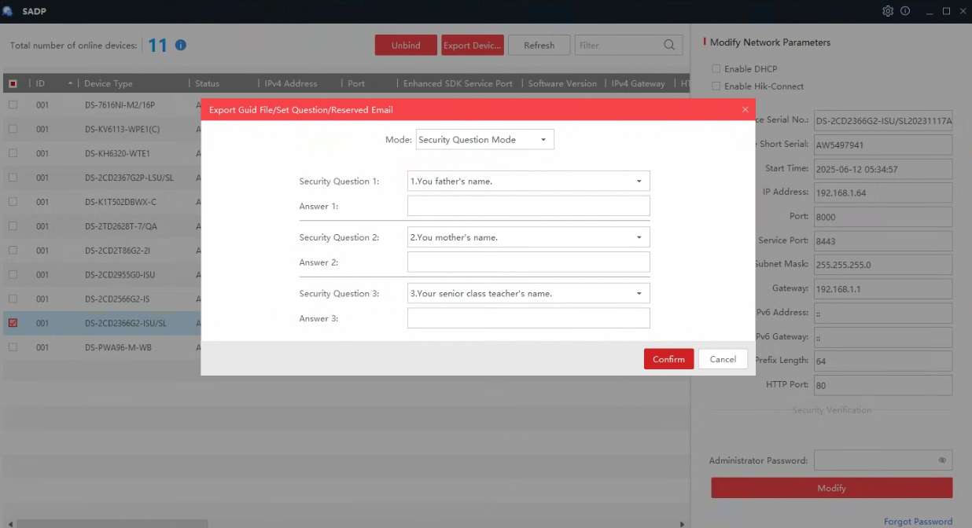
- Fill out Security Question page, confirm and click on the X to close. Useful if password is forgotten
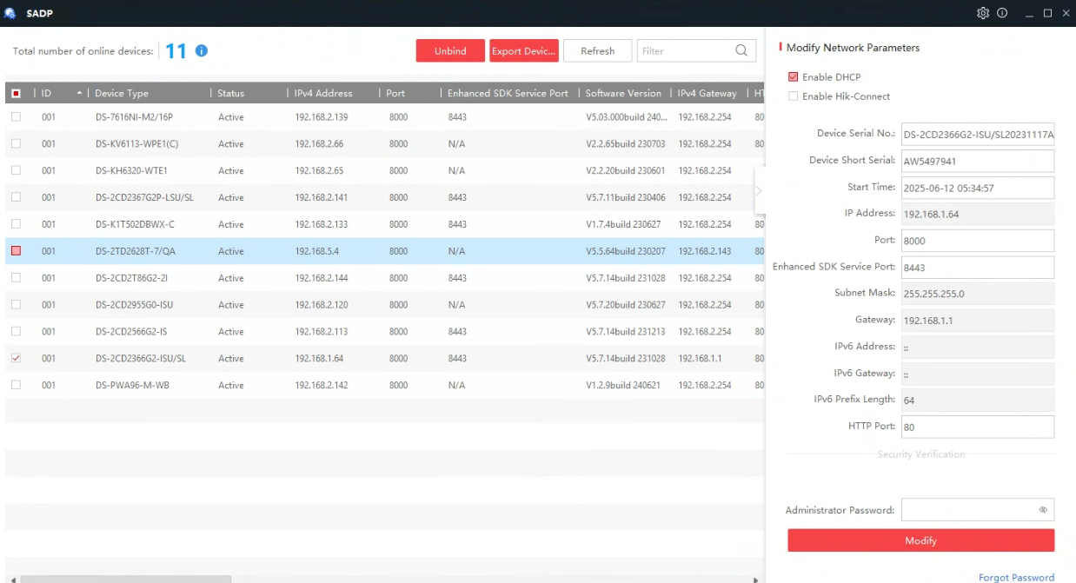
- Enter Static IP address detail for camera or click on DHCP to automatically assign the camera an IP address, enter password and click Modify. The camera will reboot and will reappear with the new IP address
Access the NVR GUI via monitor or Web Browser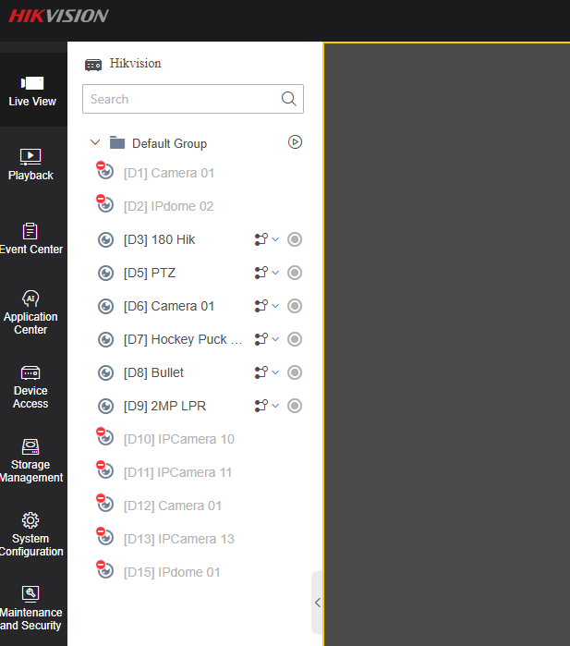
- Click on Device Access
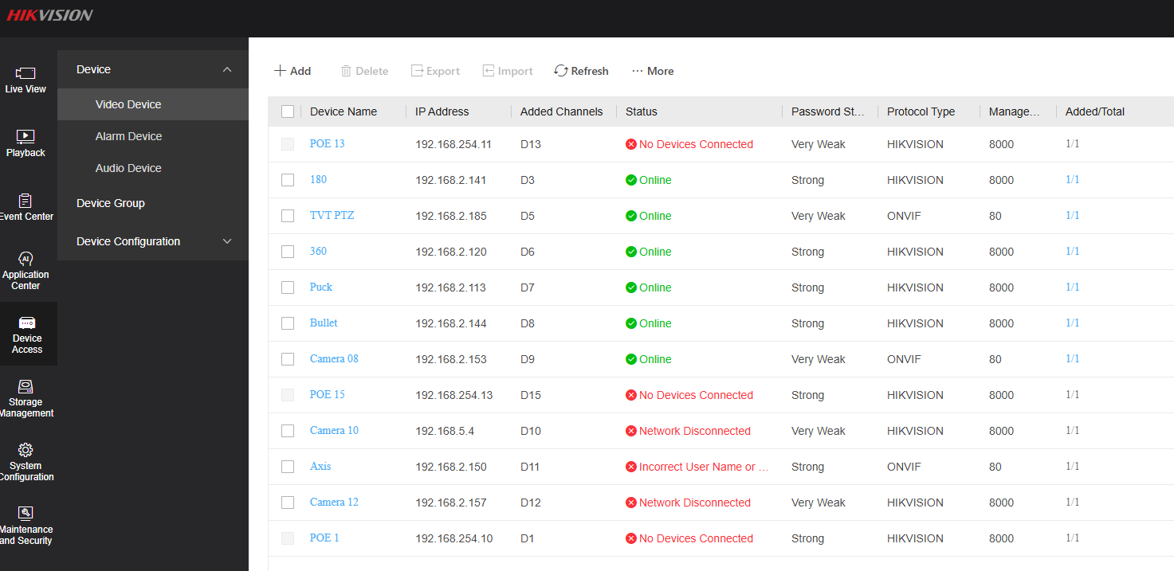

Click on Add and enter the Camera details to add to the NVR. Scroll through the list or manually enter the camera details/password for the camera and click OK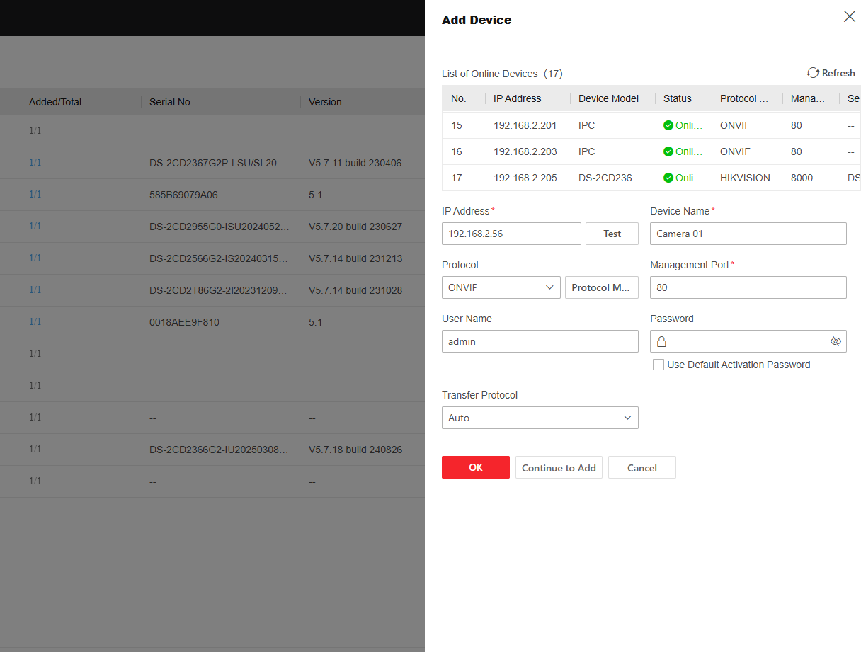

- Once connected, camera will show as Online. Repeat process for all other cameras on the Poe network
