How to program IP camera on Poe switch and connect to NVR

- Using IPTools 3.0 find the cameras on the network. Make sure your PC and NVR is connected to the same network.
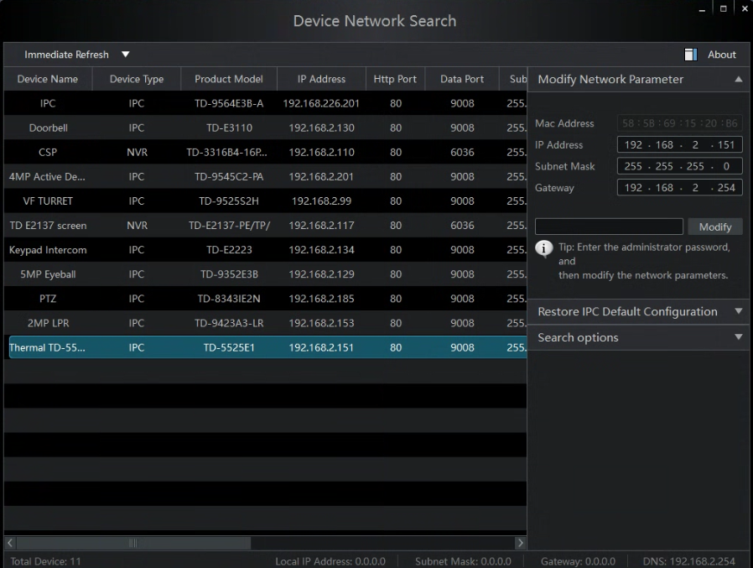
- Once the cameras are showing on the list there are a couple of ways to change the IP address of the camera for the site’s network.

- New camera- not activated. Double click on the camera’s IP address and this will open up in a default web browser.

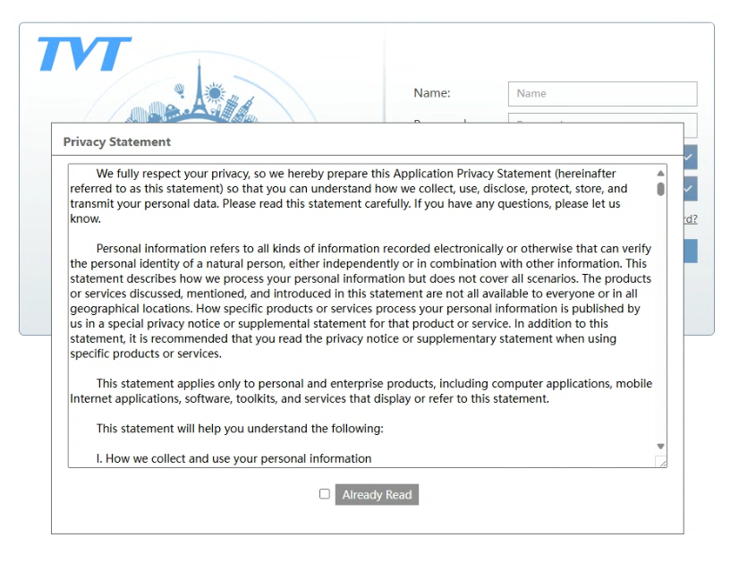
Read the Privacy Notice or select already read.
Create new password, confirm and select OK

Log in with new created password.
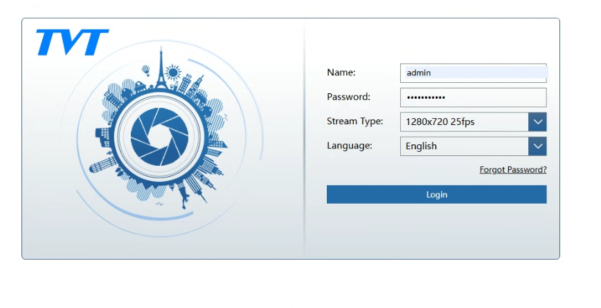
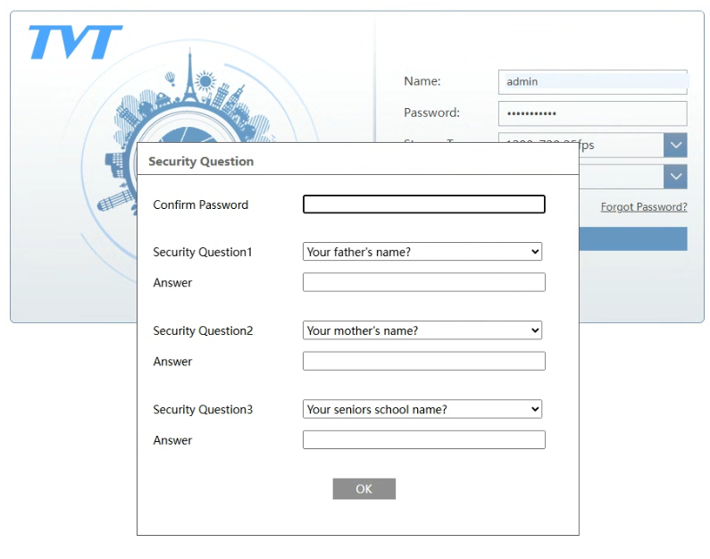

Complete the Security Question screen.

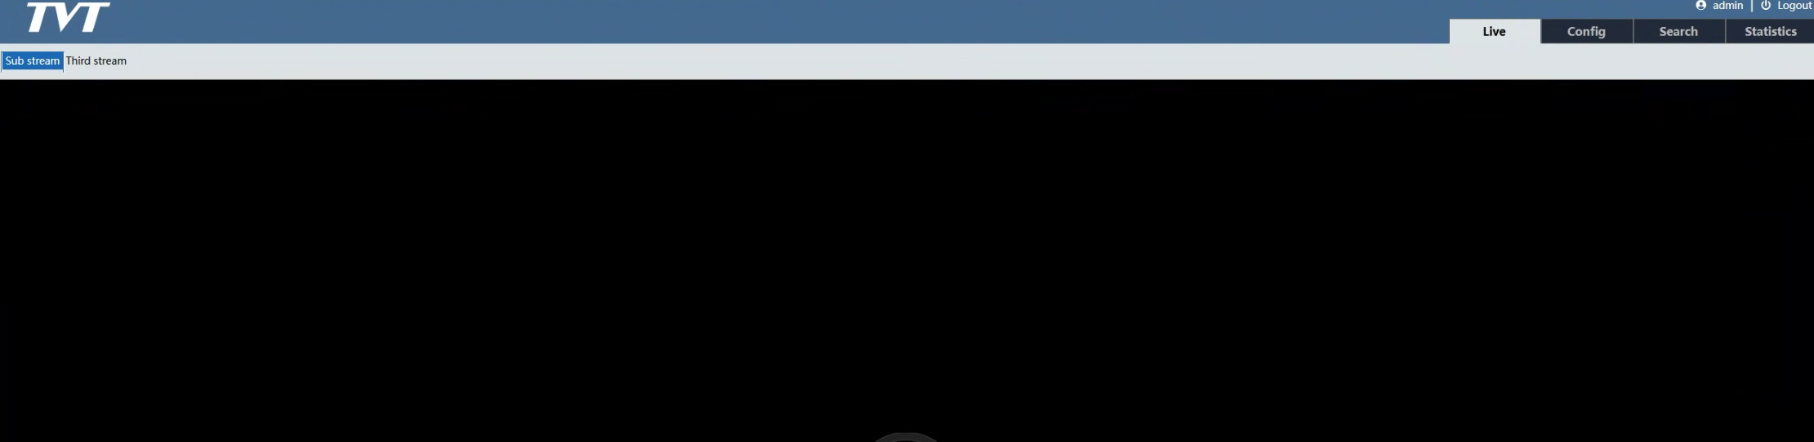

Select Config

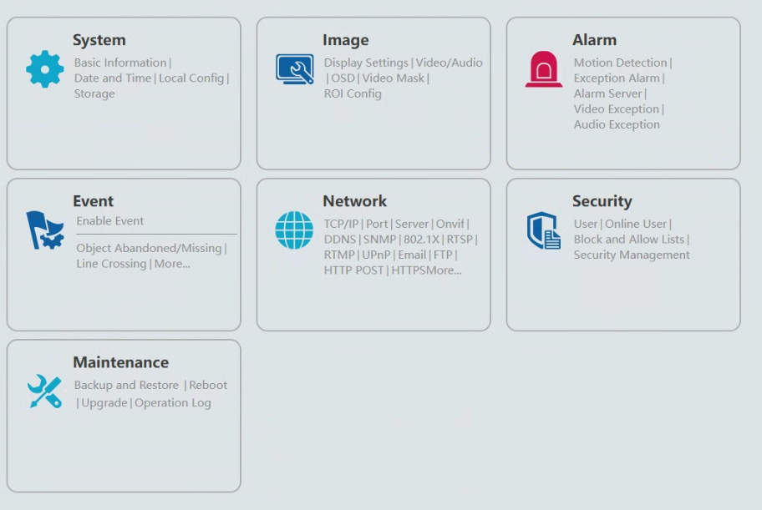

Select TCP/IP in the Network section

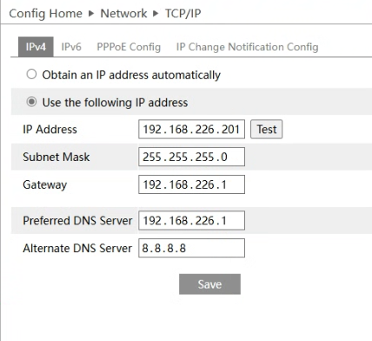

Change the IP address to suit your sites’ network and select SAVE. This will change the camera’s IP address and will restart the web application and will go back to the log in screen with the new IP address.

- If the camera already has an active password

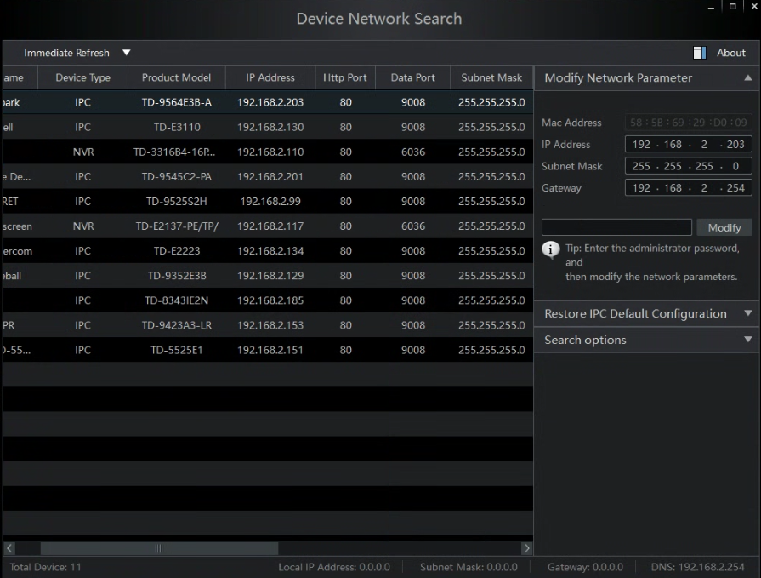

Select the camera by a single click on the IP address and then alter the IP address details on the right hand side and enter the camera’s password and click Modify

Connect to the NVR via IPTools by double clicking on the NVR’s IP address. Log in to NVR and then select Function panel, Camera and then Add Camera.

A list of all the cameras will appear on the screen. Select the camera/s you want to add by clicking on the square next to the number of the camera on the left hand side and then select Add.

Once added, select Manage Camera. A list of all cameras connected to NVR will appear. If successful, the cameras will show Online.

