Access door setup for Bosch 4000

To enable Door via Codepad:
Go to location 13098 and choose how many doors are required.
Default is 0 – All doors disabled
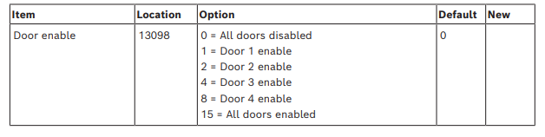

Codepad assigned door:
This option is assigning door or doors to codepads for adding access cards
and cycling door operations. Each codepad and be assigned door/s.
By default this is set to [15] – No door is assigned
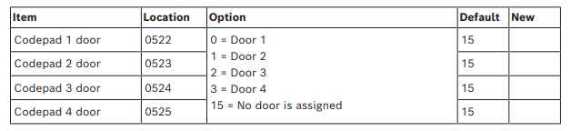
If this is left as [15] – you will not be able to:
- Cycle the door operation
- Add access card users via the codepad

Assign Door 1 to Codepad 1
Location 552 – Enter 1 - to assign Door 1 to Codepad 1
Enter 1234 # 552 # 1 *

Assigning Access Card/Tag to User:
- Using the Master Code, you can add/ delete access cards/tags just like user codes and remotes.
- Access card credentials are between [601 – 664] which like the remotes are assigned to users 1 - 64 respectively.
- To add an access card credential:
Enter Master code + 1 # + 601 + # Present card at reader (2 beeps are heard when successful).
Enter 25801# 601# Present Card/tag at reader
- To delete access card/tag
Enter Master code + 1 # + 601 + # then * (2 beeps are heard if successful).
Enter 25801# 601# * to delete

As mentioned, there are 32 zones on the 4000, there are an additional 4 zones for the access door control. One for each door module [ B901]
These are programmed to same way a normal panel zone and uses the same structure as the 32 zones on the 4000.

- These zones will show up as zones 129 – 132 on the alarm system
- Program door zone 129 for entry delay 1 on the Door module 1
1234# 13252# 2 *

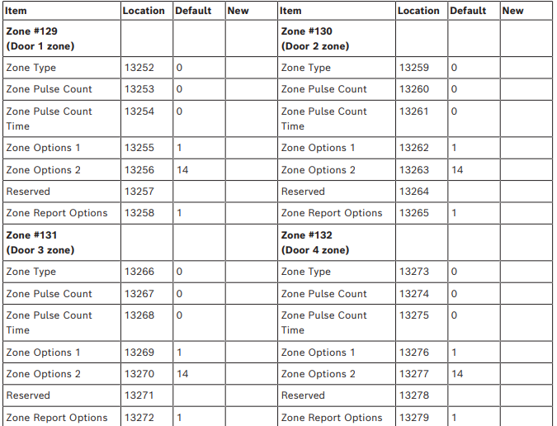

Access Door Programming Via Alink Software
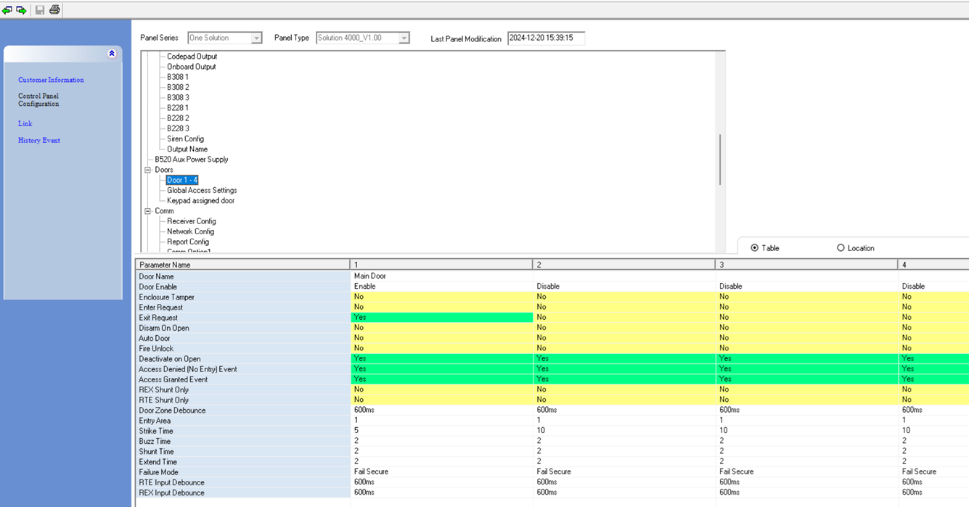
Common Door Options
Door Name - Name of Door
Door Enable - Yes or No
Exit request - RTE device
Auto door - Unlock during disarm
Fire unlock - Unlocks during FIRE event. Zone to be programmed as a fire zone-type 13
Strike Time - Unlock time of door
Default is 10 seconds
Failure Mode:
Fail Secure - Door remains locked when B901 module is offline
Fail Safe – Access module releases door when B901 module loses communications with 4000 panel

Global Access Settings:
- This is for selecting which weigand format to use. Currently only 3 options.
- 26 bit, 37 bit No site code and 37 bit with site code
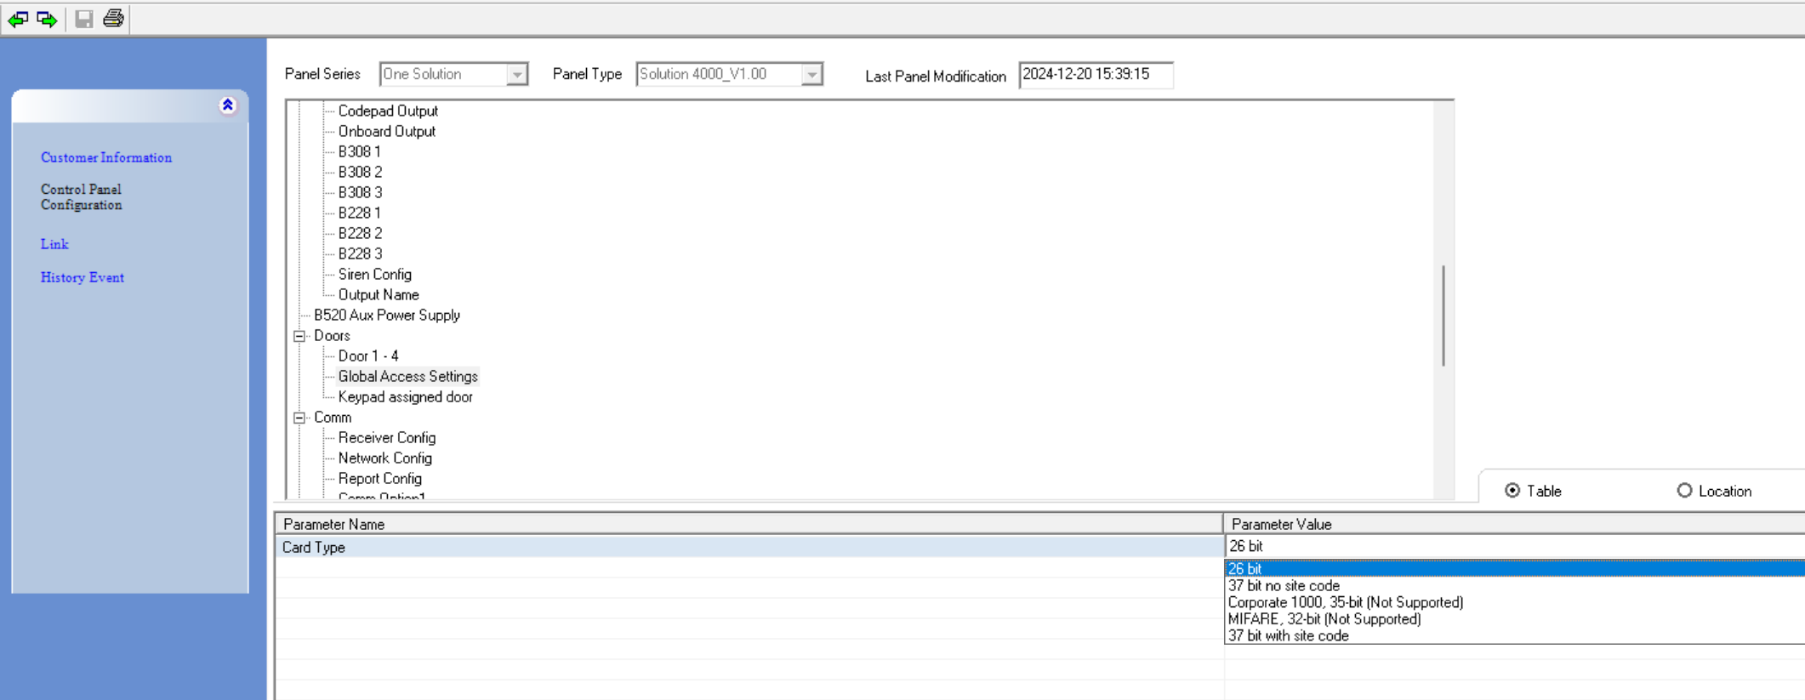

Keypad Assigned Door:
- Assign a codepad to an access door.

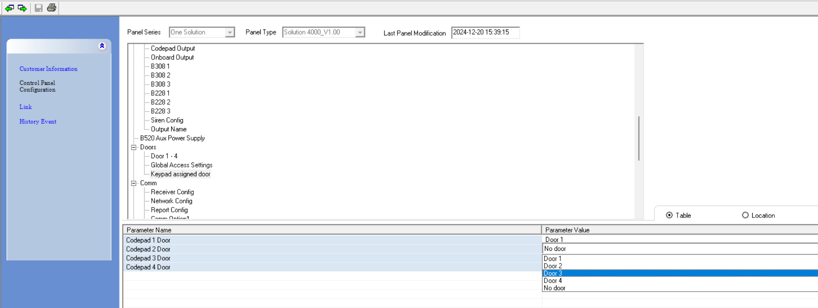
Assigning user cards/tags:
Enter User Name, Area User Authority, Site Code and Card Number details if required
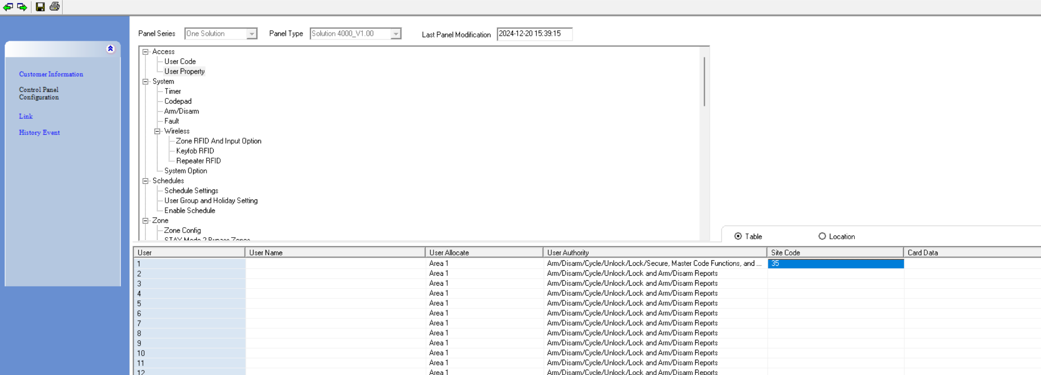

Zone Programming
- Here you can program the zone for each Door module.
- Each Door module has one zone available for Door input monitoring

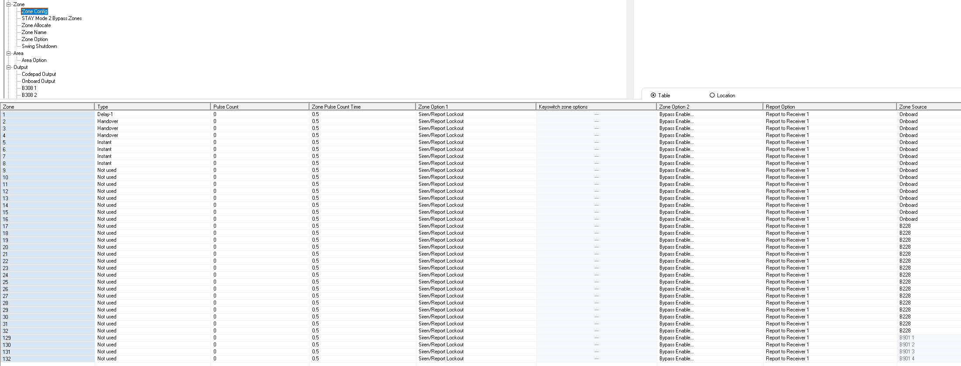

Schedule Settings
- This is where you create schedules/timezones for Doors and User Groups. 2 x schedules will need to be programmed per event eg: Door unlocked during business hours – 1 for unlock time and 1 for lock time
- Function: No Schedule - Disabled
Lock Door – Locked during valid Schedule
Unlock Door – Unlocked during valid Schedule
Secure Door – Locks during valid Schedule
Activate User – User allowed access during valid Schedule
Deactivate User – User denied access during valid Schedule

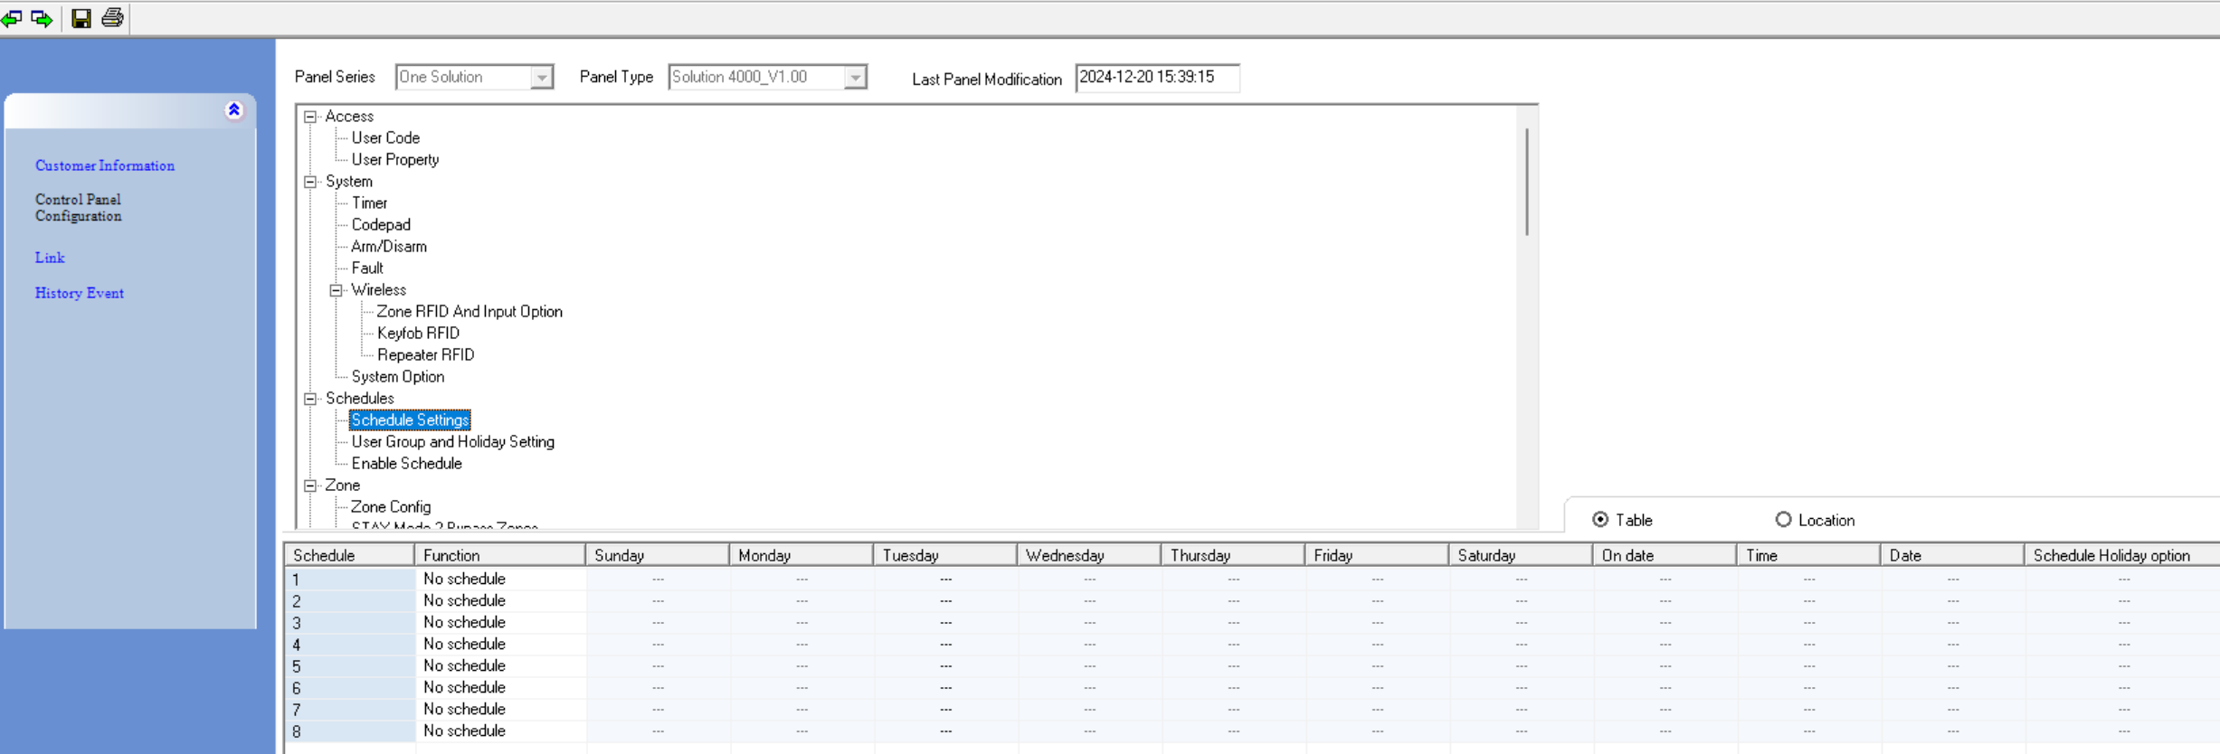

Sunday through Saturday Yes/No – enable or disable for each day.
- On Date Yes/No – enable/disable user to edit schedule via codepad.
- Time Time of day that the schedule starts or is valid
- Date Start date for the event schedule to start – day and month only
Schedule holiday option
3 x options: Ignore Holiday setting: Schedule still valid during holidays programmed
Holiday will do schedule: Will operate schedule if no days set in schedule
Holidays are exception day: Schedule does not operate on holiday programme

User Group And Holiday Settings
- Up to 8 User Groups
- 1 Holiday schedule
Users that are assigned User Groups can be assigned to a schedule to restrict access to the door.
- Select [View in Setting] section of the User Group
- Select the users you want have in that User Group and click OK

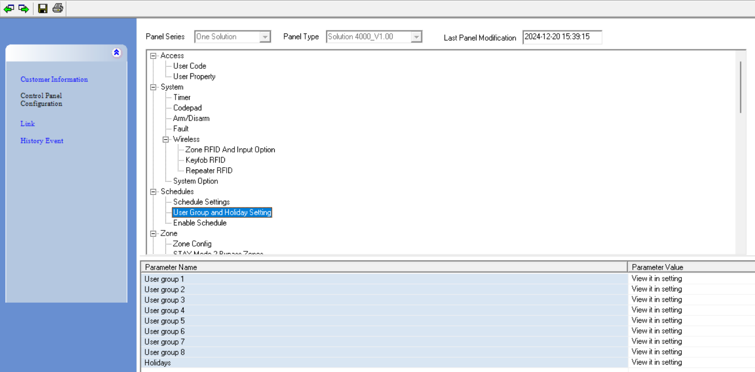
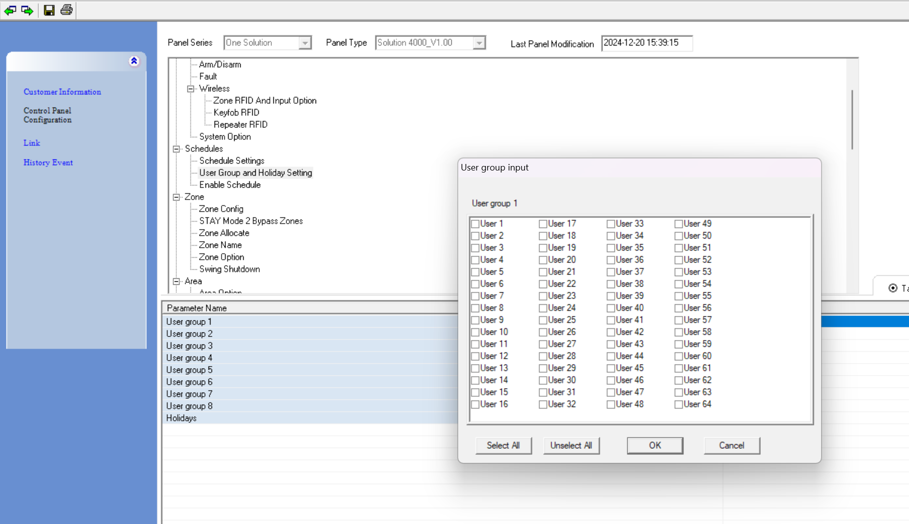

User Group And Holiday Settings
- Up to 8 User Groups
- 1 Holiday schedule
The Holiday schedule is also setup in this area.
- Select [View in Setting] section of the Holidays section
- Select the dates on the monthly calender and select OK when done
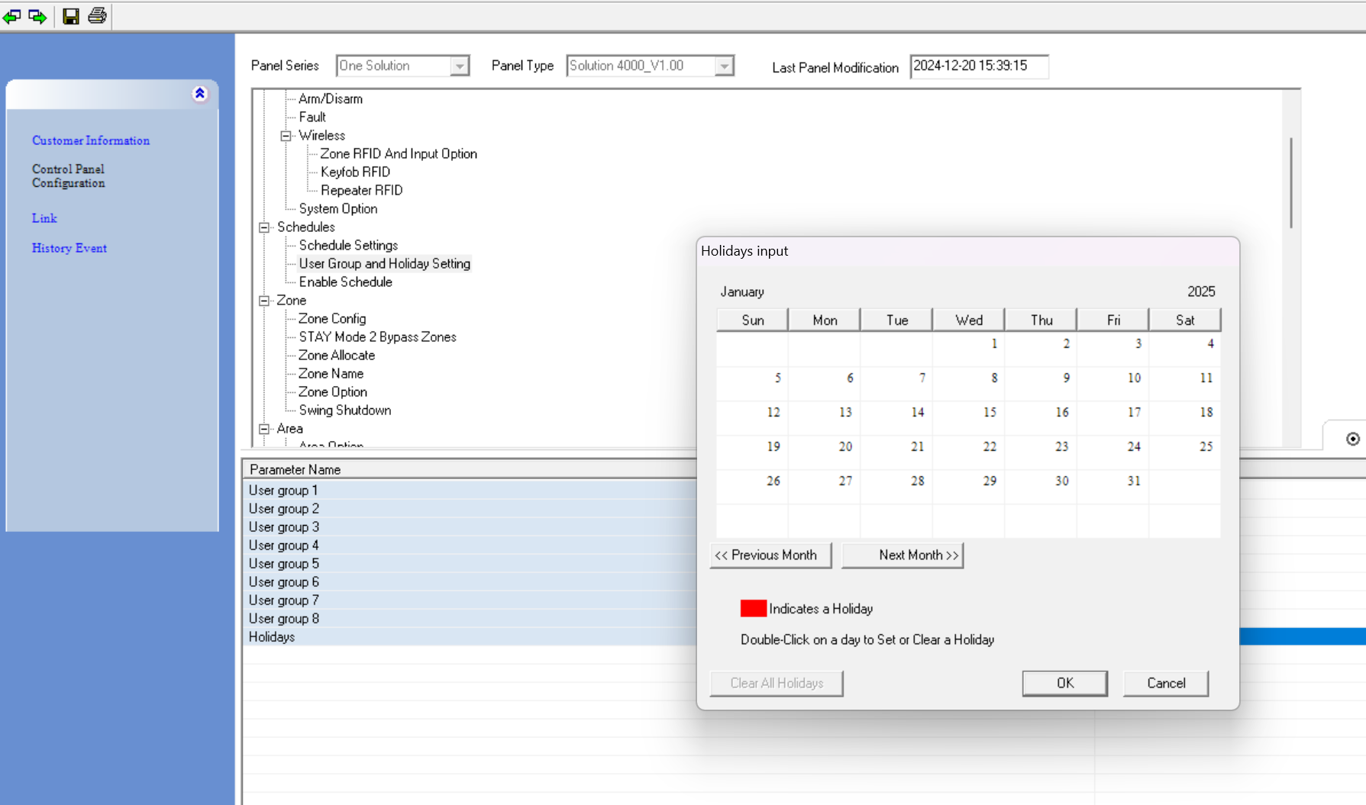

Enable Schedule
In the Option section, just enable the schedule number to activate that schedule

